Task 1: Rule-Based Disease Diagnosis System

Objective
To develop a rule-based expert system that predicts possible diseases based on user-entered symptoms using predefined IF-ELSE rules.

Description
Developed a Python-based AI Diagnosis Assistant that accepts symptoms as user input and predicts possible diseases using predefined IF-ELSE rules. The system also displays the severity level and provides basic health recommendations.

Technologies Used
- Python
- Jupyter Notebook
- Pandas
- NumPy

Activities Performed
- Collected symptom inputs from the user.
- Implemented rule-based decision logic using IF-ELSE statements.
- Matched symptoms with predefined disease conditions.
- Displayed disease prediction, severity, and health suggestions.
- Tested the system using different symptom combinations.

Diseases Included
- Common Cold
- Flu
- COVID-like Infection
- Food Poisoning
- Migraine
- Diabetes Risk
- Heart Disease Risk
- Dengue-like Symptoms
- Malaria-like Infection
- Gastric Problems
- Asthma Risk
- Dehydration

Outcome
Successfully developed a rule-based disease diagnosis assistant capable of providing preliminary disease predictions based on user symptoms.
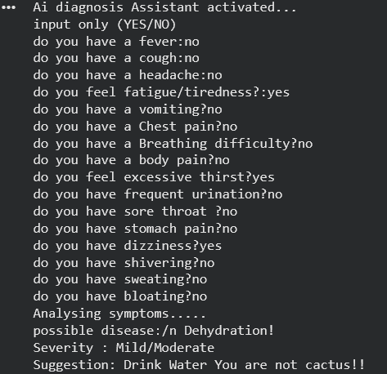

Skills Acquired
- Rule-Based Systems
- Expert Systems
- Conditional Programming (IF-ELSE)
- Python Programming
- User Input Handling
- Basic AI Concepts

